Mini Cases 2022-23

Mini Case 1: The Coca Cola Life

Coca-Cola is the best-selling soft drink in most countries and was recognized as the number one global brand in 2010.
In 2014 the company global sparkling beverage volume grew 1% in full year, driven by growth in brand Coca-Cola, Sprite and Fanta. The business was very stable in western countries. Coca Cola brand lunched the last new product in 2006 (Coca Zero) and in 2014 Coca Cola launched in the world a new Coca (Coca Cola Life).

Coca-Cola Life was a Coca Cola product launched in Argentina in June 2013 and in Chile in November of the same year. It was the first version of the soft drink to be made with stevia and sugar as sweeteners. Coca-Cola Life was launched in the UK in August 2014, in Ireland since December 2014, in the United States, Mexico and Sweden since September 2014, and in Belgium, France, Estonia, Germany, the Netherlands, Norway and Italy since 2015. It was a low calorie version of Coca-Cola, with 27 kcal / 100 ml, containing 60% of the calories of classic Coca-Cola. The drink was available in glass bottles, plastic bottles or aluminum cans. The logo is a small green leaf. In 2020 the product was withdrawn from the world market.
Questions (please answer using the “marketing process” approach. You can use ”external information” )

Why did Coca Cola launch a new product in this “crowded” market?
What was the value proposition of Coca Cola Life?
Which segment was the target for Coca Cola to get in Europe and USA to launch Coca-Cola Life and why?
Why was the launch of this product unsuccessful in Europe and around the world?

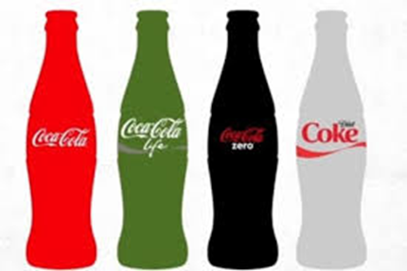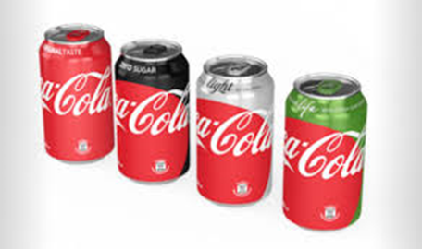

SuperSalad SPA.

SuperSalad SPA is an Italian company producing processed vegetables (frozen vegetables, prepared salad, fresh cut vegetables, preserves), founded in Forlì (Italy) in 1980 by Dott.Calligari. The company has grown over time, including through acquisitions of competitors in the industry. In 2018 the revenue is expected to increase by 5%, to about €450 million, with a stable profit of €22 million. SuperSalad sells mainly in Italy, with a small presence in Austria and in Switzerland.

In Italy, SuperSalad generates about €140 million by producing under private labels for large retailers. The rest of the turnover is made with the brand SuperSalad, among which €50 million from preserves under the brand CheBontà, mainly sold through major retailers such as Esselunga, Coop, Carrefour, Auchan, etc. Another important channel in the market of processed vegetables is HoReCa (hotel-restaurant-café), even if SuperSalad has little presence on this channel in Italy.

The market is growing all around Europe. Especially, in France there is an increase of 10% each year. In 2019, SuperSalad’s strategic priority is entering the French market with the objective of getting 6% Market Share in 3 years.

Processed vegetable market in France is estimated to be €1,5 billion in 2017. The market leader, a French company Bonduelle, has a strong command of 40% market share. 74% of Bonduelle’s turnover comes from retail; 20% comes from HoReCa.

Questions

- In entering the French market, what should SuperSalad try to do to create and increase the brand awareness? (please, provide the most reasonable tools and levers that can be used considering the target of the company)

- What would be your suggestions for distribution channel for SuperSalad in selling processed vegetables in France? (please, discuss the most reasonable channel that can be used considering the target of the company)

MuyLindo

MuyLindo, a small Spanish company, markets a variety of cleaning products, with total revenues of 85 million euro. Although the company competes with major multinational brands, it has had a strong success in Spain. One of its principal products is “Elimina Todo”, a fabric stain remover available only in liquid form. Although “Elimina Todo” is superior to international brands as a stain remover for most types of stains, sales have been declining, in a market that is increasing 4%
MuyLindo is strong in the traditional retail market, but It is a minor player in Hyper and Supermarkets. Due to the quality of the product and the Business Mission of the company, discounts are not MuyLindo’s customers.
After doing some market research, the new PM (hired from an international competitor) finds that customers are switching not because of the superior cleaning ability of the national brands but because these brands are available in aerosol sprays. Consumers find the aerosol sprays much easier to apply and less messy than “Elimina Todo”, which tends to spill into areas of the fabric other than the stained area. Aerosol sprays markets is increased 8% last year.
The PM realizes that to remain competitive, an aerosol spray should be offered. After a short discussion with Research and Development, the PM finds that the propellant necessary to make an aerosol spray for “Elimina Todo” contains hydrocarbons. But he is worried, he has read that hydrocarbon contribute to the creation of ozone in the lower levels of the earth’s atmosphere. The new environmental trend of the consumers is against the hydrocarbons for pollution reason, and the trend seems rapidly increase.
If he does not launch a new product the sales ‘ll decline. What the PM has to do?

Questions
1. What steps the PM should consider before launching the new product (show methodologies and Ideas for this problem)?

2. What do you think about the possibility to add new distribution channel to lunch the product?

NIKE, Inc - Mini Case

Nike, Inc. is an American multinational corporation that is engaged in the design, development, manufacturing, and worldwide marketing and sales of footwear, apparel, equipment, accessories, and services. It is the world's largest supplier of athletic shoes and apparel and a major manufacturer of sports equipment, with revenue in excess of $39.2 billion in its fiscal year 2017, with a 9 % increase on a currency-neutral basis and a net income to $4.03 billion.
Nike grew internally, with few acquisitions of other brands (including Converse All-Star in 2003).
What are in your opinion the reasons of the big success of this company? (Please answer using a structured marketing approach)

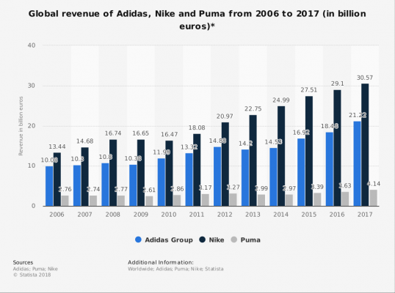

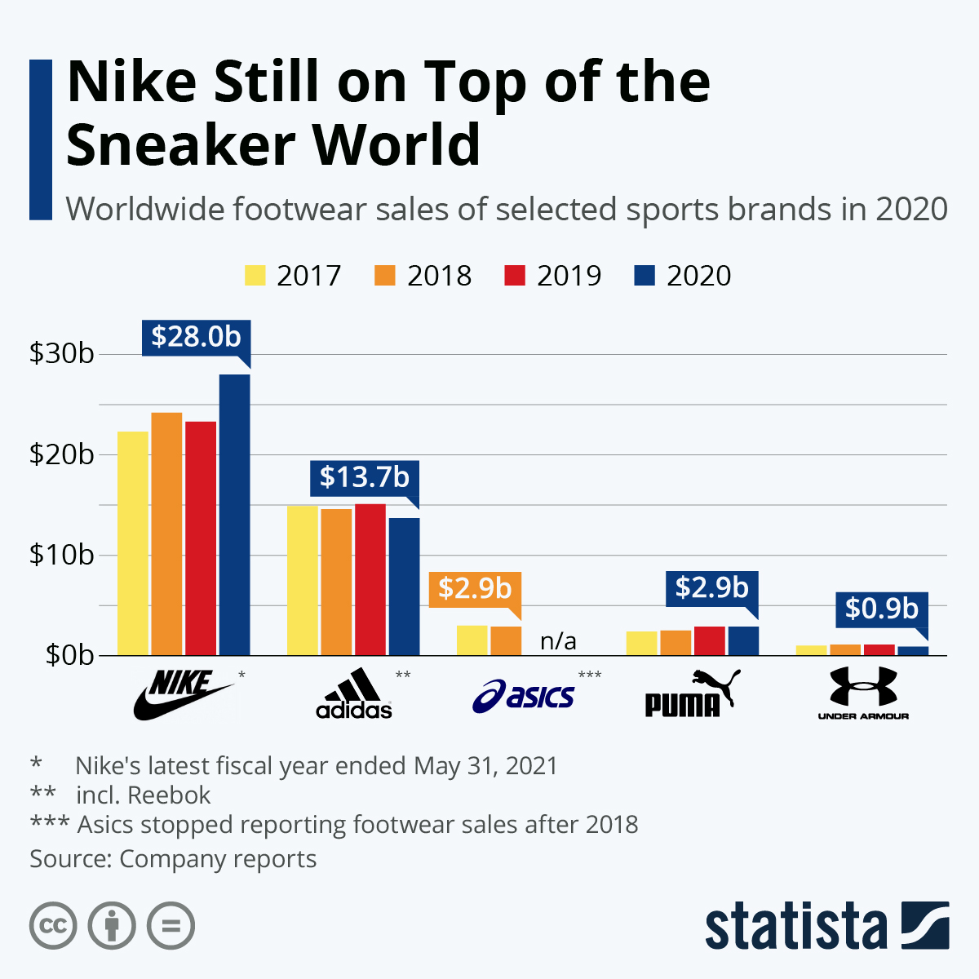

British Airways - mini case

British Airways (BA) is the flag carrier] and the largest airline in the United Kingdom based on fleet size, or the second largest, behind easyJet, when measured by passengers carried. In January 2011 BA merged with Iberia, creating the International Airlines Group (IAG), a holding company registered in Madrid, Spain. IAG is the world's third-largest airline group in terms of annual revenue and the second-largest in Europe. It is listed on the London Stock Exchange and in the FTSE 100 Index. The turnover (£12.22 billion) and the profit8£1.44) in the last years are increasing.
You are a manager of France subsidiary and you are analyzing how improve the service of the route Paris- London and how to fight against Virgin Air, Easy Jet, and other competitors, including the train Eurostar, to gain more customer and keeping a good marginality.

Question 1
What are main characteristics of a service (including the airlines) that differentiated the service from the product (general description)?

Question 2
What are the elements of the service that you have to consider for the airlines companies, including British Airways (specific for airlines)?

Question 3
Maybe you could recover some marginality by changing prices. To understand how to define the best price on the market, compared to competitors, which methodology you must apply? Make a detailed example

Question 4

The Airbus A320 has a full capacity of 150 passengers. On flights from Paris to London, the load factor in the Airbus A320 is normally 82%, with an average seat price of £ 96. The transportation’s costs in term of fuel increase is £ 6.8 for each passenger. On the average, each passenger buy £14.4 on food and merchandising. In the simulations about the change in pricing that you are doing for the next month, there is a first hypothesis with a Load factor at 89% with an average price of £ 92, a second hypothesis with a load factor of 93% with an average price per seat of £ 88, a third hypothesis with a load factor of 95% and price £ 85.. What are the best and worst seat price hypotheses and why?

